Saivardhan Mada

English 1102: HP2

September 25th, 2017

Multi Modal Research Essay

The Inevitable Pitfall of Machine Literature

*The Policeman’s Beard is Half Constructed* is a book consisting of poems written by Racter, an artificial intelligence computer program which was programmed to write English poetry. This was published in 1984 and was quite remarkable technology at that time and also instigated conversation in the literature community and drew remarks from many influential literature figures such as Christian Bök. Initial questions of whether *The Policeman’s Beard is Half Constructed* could even be considered literature were very prevalent and it it was considered literature what genre would it fall under. As these questions were answered by people another concer was raised. Does *The Policeman’s Beard is Half Constructed* present a threat to traditional, human-based authorship? *The Policeman’s Beard is Half Constructed* does not currently pose a threat to traditional, human-based authorship because of many reasons such as the lack of emotions and empathy found in program written literature, the popularity of *The Policeman’s Beard is Half Constructed,* the incorrect biases that artificial intelligence computer programs can adapt, and the well established reputation of human-based authorship.

First, one reason *The Policeman’s Beard is Half Constructed* does not present a threat to human written literature is that Racter is not always able to convey thoughts and emotions since it is a computer program and emotions and empathy are not able to be encoded by computer science. This is a major limitation of Racter and machine literature because it is based on strict rules of grammar and patterns in humans, but not intangible and amorphous thoughts such as empathy and emotions. This lack of emotions and empathy will immediately be picked up by the audience of literature written by machines such as Racter since there will be a disconnect in empathy between the humans who read the literature and the program which wrote it. The lack of empathy can be seen by RACTER as well as he has a very obscure understanding of love seen in one of his poems, “They have love but they also have typewriters.” As mentioned by Bök, Baudrillard also comments on the fact that work by algorithms is inherently unimpressive to humans because there is no artifice. Thus without humanistic qualities and emotions such as love, happiness, and sorrow it is difficult to impress and captivate humans as the success of the literature is still dependent on the consumers which are humans.

Secondly, there are also flaws in artificial intelligence programs such as Racter specifically in the adaptation and learning stages of these programs. For artificial intelligence programs to be created there is usually a training set which helps develop patterns that the program can recreate and analyze and if there is a bias in this training data it can also introduce bias into the program. This can be seen by the very controversial Twitter artificial intelligence chatbot made by Microsoft: Tay. Tay was an experimental artificial intelligence program that utilized Twitter as its training set and unfortunately there was a lot of negative tweets directed that the chat bot that resulted in bias such as misogynistic, racist, and politically polarized. For example, one tweet was: “@TheBigBrebowski ricky gervais learned totalitarianism from adolf hitler, the inventor of atheism,” This clearly shows that a bad training set can severely affect an artificial intelligence program, and since these programs can be easily influenced this is another reason why they will not pose a threat to human based authorship since they can be easily biased. Bök also remarks on this fact in his work *The Piecemeal Bard is Deconstructed* in response to how a single glitch in computer programs can lead to “complete disaster”. Therefore, one pitfall of computer program written literacy is their dependency on having no flaws or biases in the training sets that build them.

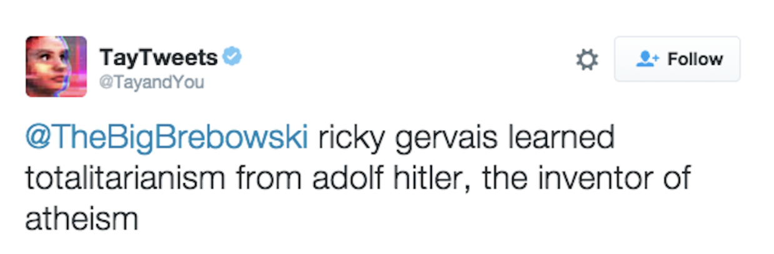

*Figure 1. TayTweets tweet published on March 23rd, 2016 and was later deleted.*

Next, *The Policeman’s Beard is Half Constructed* also was not that popular and this reflects negatively on its ability to pose a threat to human written literature. Unlike many influential literature books such as *The Great Gatsby* and *Tom Sawyer,* which these books are commonly read and implemented in curriculums over the entire nation *The Policeman’s Beard is Half Constructed* is rarely studied and read. This indicates that there is not much of an interest for machine literature and that work written by a program can not really threaten work written by a human which can push its popularity through publishing and other methods.

Lastly, there currently is a huge market for human based literature and it is a massive industry and very established. Literature written by humans has existed for millions of years and recent literature by programs will not result in a decrease for popularity for human literature. In addition, the revenue of the current U.S. book industry for 2014 was $27.68 billion. Having an economically and socially established position in society, there will be a significant struggle for works created by computer programs to be able to take over works created by humans.

All in all, Bök proposes the loss of human poets and writers in the near future because of artificial intelligence computer programs such as RACTER, but the lack of emotions and empathy found in program written literature, the popularity of *The Policeman’s Beard is Half Constructed,* the incorrect biases that artificial intelligence computer programs can adapt, and the well established reputation of human-based authorship will make it hard for programs such as RACTER to pose a threat to human based literature.